**HEALTHMATE**

**User's Manual**

**CSCI-P465/565 (Software Engineering I)**

**Project Team**

**Sakshi Sitoot**

**Ratan Vadapalli**

**Vikram Kolla**

**Himani Patil**

**Satwik Kulkarni**

**1. Product Overview**

Healtmate is a wellness tracking web application that allows users to create their profiles and track their wellness journey for free. With the option to login using Google credentials, users can easily access the application and start tracking their fitness goals. Additionally, fitness professionals can also create their profiles and post content related to workouts or diet, which users can view on their dashboard.

Users can also subscribe to a particular fitness professional, and they will receive the content on their dashboard. They can rate the posts and leave comments, providing valuable feedback to both the fitness professional and other users. All the ratings and reviews are visible to all users, allowing them to make informed decisions about which posts to follow. The application also includes a chat feature that enables users to communicate with a fitness professional, and vice versa. However, the fitness professional can only initiate a chat with a user if the user has messaged them first. Overall, Healtmate provides a comprehensive wellness tracking solution for both users and fitness professionals.

Users can also update their profiles, providing a customizable experience. From the user profile page, they can update their profile picture, add personal information, and track their fitness progress. The platform provides a centralized location for all wellness-related activities, simplifying the process of tracking fitness goals. With its user-friendly interface, Healtmate makes it easy for anyone to start tracking their wellness journey and connecting with fitness professionals for personalized support.

**2. System Requirements**

There are no specific system requirements to access the web application, as it is available through a direct link: "https://healthmate-frontend.onrender.com/". Users can access it on browser using a laptop, pc or mobile.

**3. Product Installation**

The web application is designed to be easily accessible without the need for any software installation. However, in order to run it locally, the PC must have Node.js and React installed. To launch it locally, users can simply use the command "npm i" followed by "npm start". The "npm i" command will automatically install all the required dependencies listed in the package.json and package-lock.json files, eliminating the need for manual package installation. Users will have to run both the backend and frontend parts separately. The database is hosted on MongoDB Atlas, so there is no need for users to install MongoDB. However, if they wish to view the database, they can install MongoDB Compass and access the project database.

**4. Product Operation**

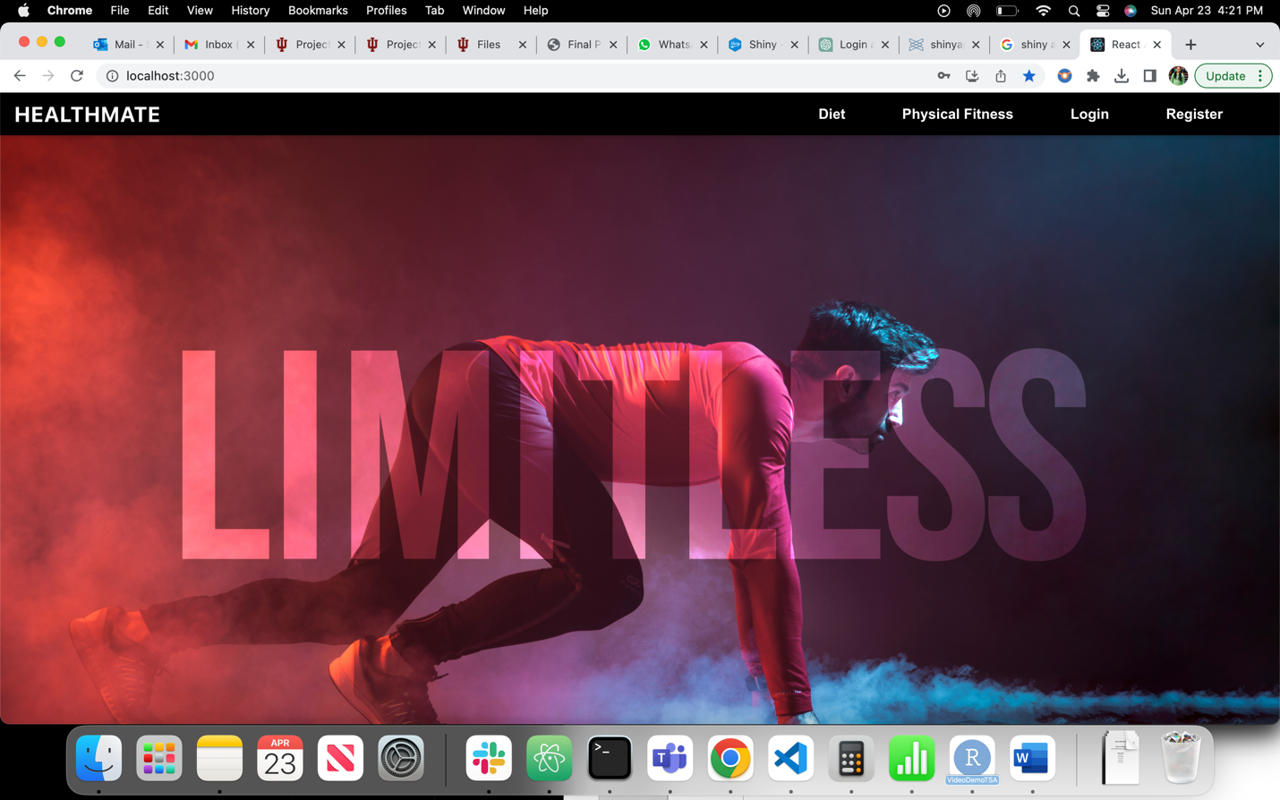

The Landing Page of the application presents the user with options to Login or register, along with basic information on Diet and Physical Fitness. To create a new profile, the user must provide a valid email address and indicate whether they are a fitness professional or a regular customer. Alternatively, the user can choose to sign up using their Google account. After registering, the user will be redirected to the Login page where they can use the same credentials to access their account. If the user forgets their password, they can click on "forgot password" and enter their registered email address to receive a one-time password. If the OTP is verified, the user can go ahead and save the new password.

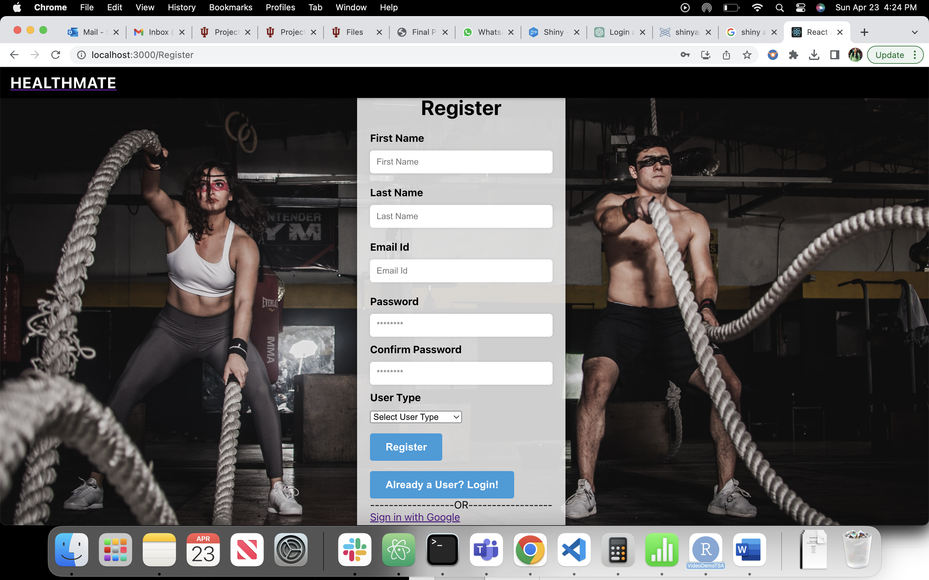

After successfully logging in, the user will be directed to either the Client dashboard or the Fitness Professional dashboard, based on their account type. A Client user will be presented with recommended posts and can access posts from various Fitness Professionals on the Posts tab. The user can subscribe to a specific Fitness Professional to view their posts on their dashboard. Additionally, users can search for specific content on the Posts page. A "Chat" tab will also be available for the user to communicate with any available Fitness Professional regarding their diets or workouts. Users can rate the content provided by Fitness Professionals and leave reviews, which will be visible to other users.

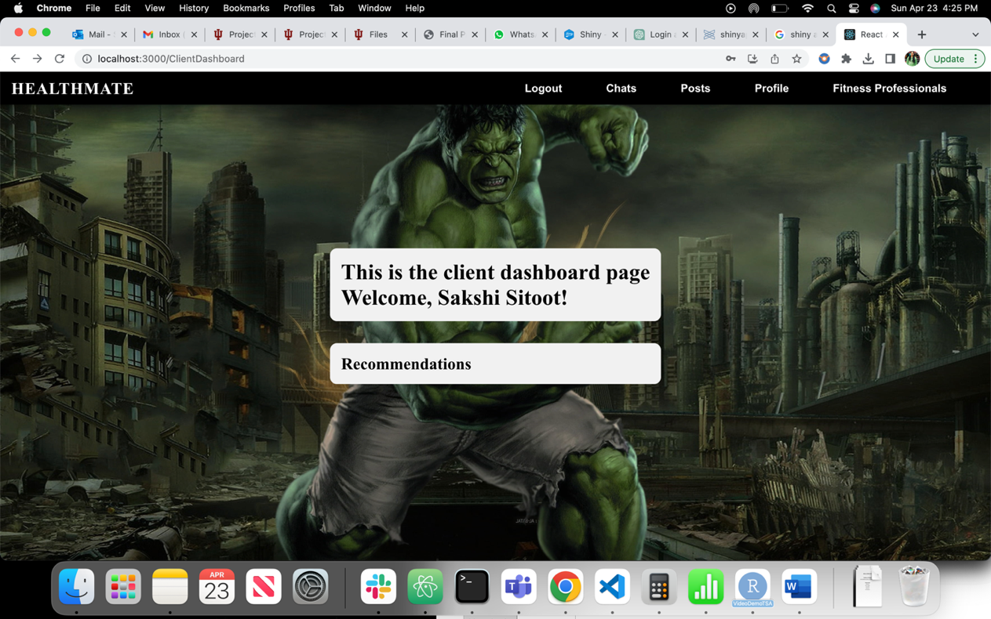

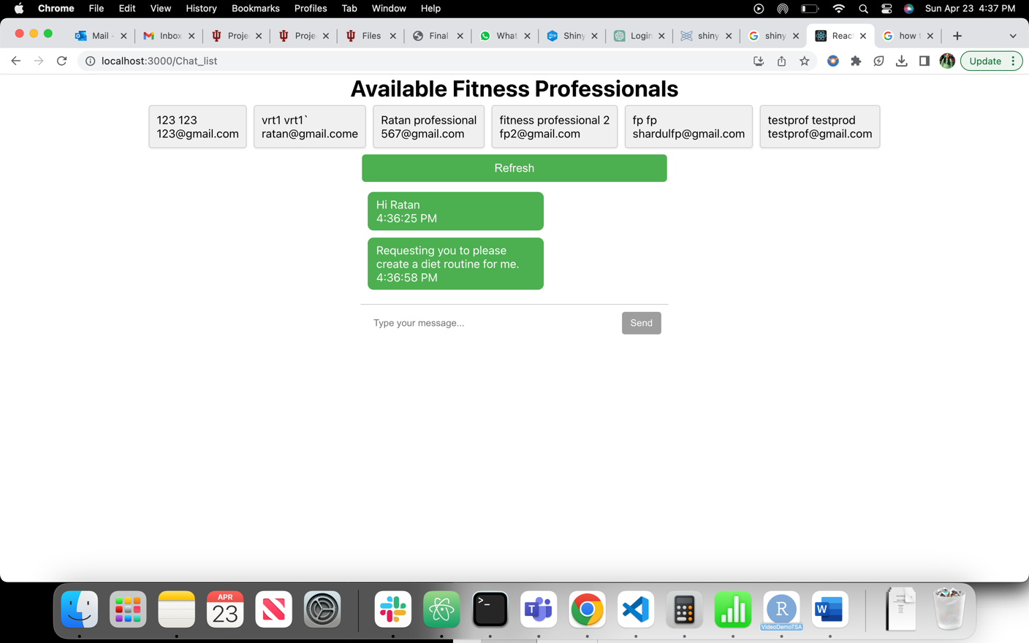

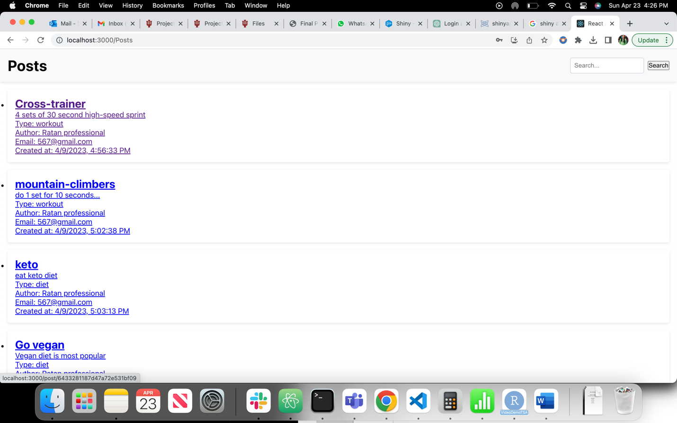

Upon logging in, a Fitness Professional will be directed to their dashboard where they can post new content, such as diet or workout posts. They can only chat with users who have messaged them; they cannot initiate chats with users directly. The latest messages will appear at the top. Both Clients and Fitness Professionals have access to a profile tab on the navigation bar where they can edit their profile and save the changes.

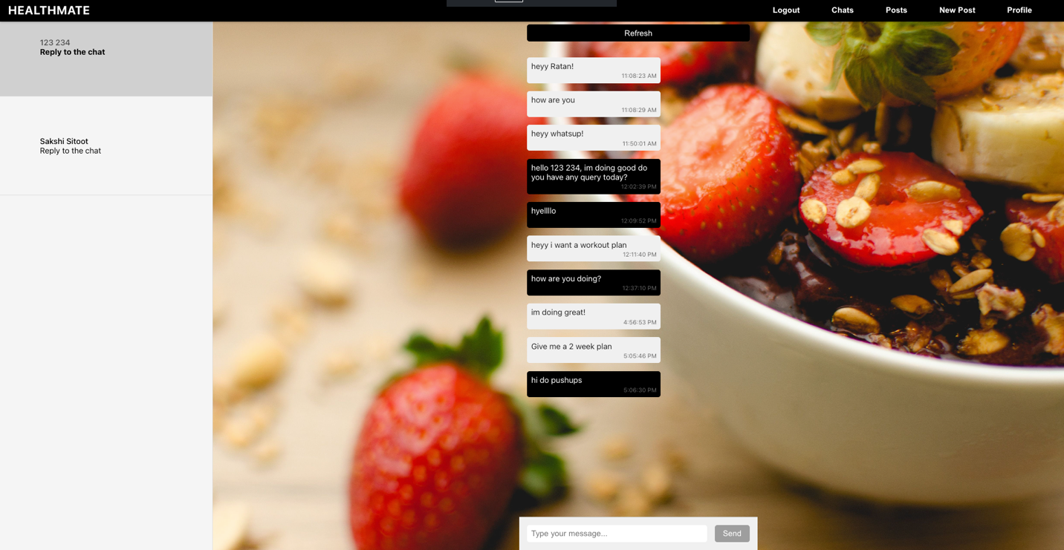

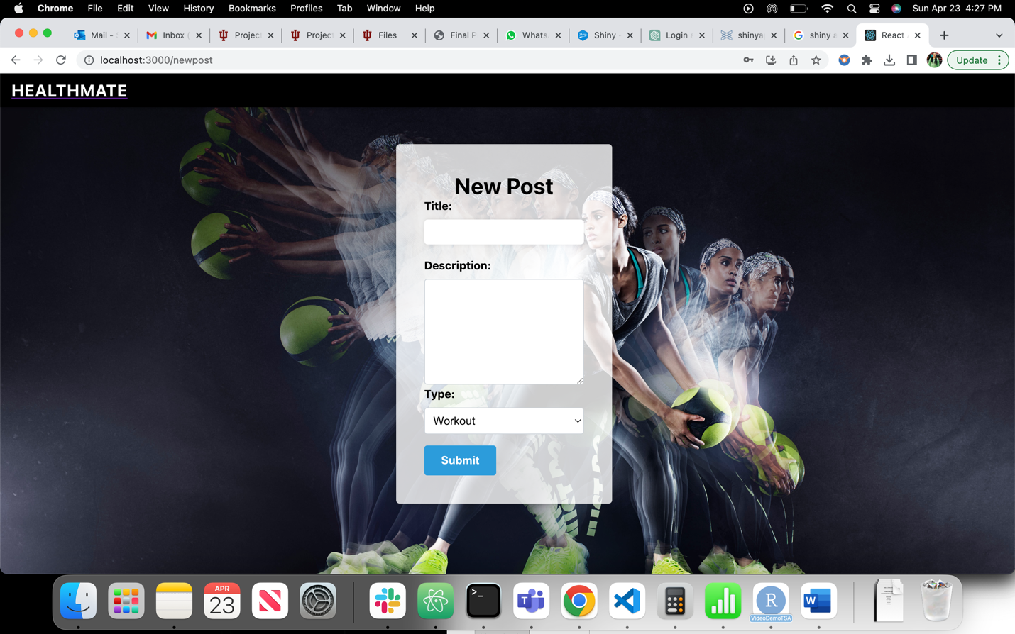

Healthmate is a remarkable application that provides a platform for users to access various workout and diet-related content. It offers a convenient and efficient way for users to access the latest fitness trends and tips, workout plans, nutrition advice, and much more. Overall, Healthmate is an excellent application that provides a user-friendly platform for individuals to access essential information to help them achieve their fitness goals.

**5. Known Defects**

The Healthmate application experiences delays in loading pages when hosted on a website. This is particularly noticeable when there are calls connecting to the backend. However, the application functions smoothly on local systems. The Healthmate team is aware of this issue and is working diligently to identify the root cause of the problem and find a solution. They are exploring various options such as optimizing the backend code, improving the server infrastructure, and implementing caching mechanisms to reduce page load times. The team understands the importance of providing users with a seamless experience and is committed to resolving this issue as soon as possible.

**Revision History**

|  |  |  |
| --- | --- | --- |
| Revision | Date | Change |
| UserManual.01 | 04-23-2023 | Added instructions and screenshots related to the usage of the application. |
|  |  |  |
|  |  |  |